Lab 6; Paired t-test

Paired T-Test and CI: Before Training, After Training

Descriptive Statistics

|  |  |  |  |  |
| --- | --- | --- | --- | --- |
| Sample | N | Mean | StDev | SE Mean |
| Before Training | 15 | 67.93 | 10.72 | 2.77 |
| After Training | 15 | 71.40 | 8.58 | 2.22 |

Estimation for Paired Difference

|  |  |  |  |
| --- | --- | --- | --- |
| Mean | StDev | SE Mean | 95% Upper Bound for μ_difference |
| -3.47 | 7.67 | 1.98 | 0.02 |

*µ_difference: mean of (Before Training - After Training)*

Test

|  |  |
| --- | --- |
| Null hypothesis | H₀: μ_difference = 0 |
| Alternative hypothesis | H₁: μ_difference < 0 |

|  |  |
| --- | --- |
| T-Value | P-Value |
| -1.75 | 0.051 |



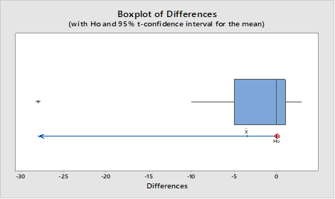

Conclusion:

1.For the paired t-test it is required that difference of two sample (before-after) is normally distribution.The graph shows that the differences is negatively skewed.

Hence,it raises the validity of the test. The alternative test could be Wilcoxon signed rank test.

2.In comparing p-value, it shows that the p-value(=0.02)is lesser than the α-value(0.05),we reject the null hypothesis that the training doesn’t increase the typing speed of the secertaries at 5% level of significance.It means that the secertaries are benefited by the typing training .

3)The average typing speed before training was 69.27 and the average after training is 71.53 which shows that the average typing spee is increased after training and increment is significant.